  

# CRM APPLICATION FOR JEWEL MANAGEMENT

**SUMITED BY,**

**Team Leader : Kaamruthina G R(922222104020)**

**Team member : Pavithra M(922222104306)**

**Team member : Megha SRI M(922222104029)**

**Team member : Nilani M(922222104033)**

**1.INTRODUCTION**

**1.1 Project Overview:**

This project involves the development of a CRM-based Jewel Management System using Salesforce. It streamlines operations like inventory tracking, price updates, billing, and customer management for a jewellery business. The project leverages Salesforce Lightning Platform to design custom objects, automate processes using Flows, and generate actionable insights via dashboards and reports.

**1.2 Purpose:**

The purpose is to replace manual processes with an automated, cloud-based Salesforce CRM that enables real-time stock updates, dynamic pricing, customer billing, and order tracking. The system enhances customer experience, operational accuracy, and business decision-making.

The purpose of this project is to design and implement a Salesforce-based CRM solution specifically for jewel businesses to:

* Centralize customer information and communication.
* Track and manage jewellery inventory (gold and silver).
* Enable personalized marketing and offers.
* Facilitate efficient order processing and billing.
* Improve customer retention through engagement automation.
* Generate detailed reports on sales, trends, and staff performance.

**2. IDEATION PHASE**

**2.1 Problem Statement:**

Traditional jewellery shops face problems like manual stock maintenance, lack of customer records, and inefficiencies in pricing and billing. There's also no integrated view of customer interactions. This leads to errors, delayed decision-making, and customer dissatisfaction. Many small to mid-sized jewellery retailers struggle with managing customer relationships,tracking sales, handling special orders, and maintaining inventory. Current manual systems or generic software often fall short of addressing the industry's unique needs.

**2.2 Empathy Map Canvas:**

**Think & Feel**

* “Are we missing out on leads because we’re not following up?”
* “I need to know who our high-value customers are.”

**Hear**

* “The customer wasn’t happy with the delay in their custom order.”
* “Can we send reminders for anniversaries and birthdays?”

**See**

* Registers with scribbled orders.
* Multiple Excel sheets for billing and inventory.

**Say & Do**

* “Call them about the pendant order tomorrow.”
* “Print out last year’s top customers list.”

**Pain**

* Losing customers due to lack of follow-up.
* No real-time inventory tracking.

**Gain**

* Higher customer satisfaction.
* More repeat purchases via automation.

**2.3 Brainstorming:**

The brainstorming phase focused on collecting diverse ideas from stakeholders—including jewel store owners, sales representatives, developers, and end-users—to define potential solutions and functionalities required in the CRM application. This collaborative ideation process aimed to understand the operational bottlenecks in the jewelry business and how Salesforce’s cloud ecosystem could streamline them.

Ideas collected during brainstorming:

● Use of custom objects for Items, Billing, Orders, and Customers.

● Automate stock management with flows.

● Dashboard for daily performance insights.

● Notifications for low inventory.

● Implement record-triggered and scheduled flows.

● Introduce validation rules to prevent data inconsistencies.

● Plan separate dashboards for different roles (sales, inventory, admin).

**3. Requirement Analysis**

**3.1 Customer Journey Map:**

The customer journey map outlines the stages a customer experiences, from the first interaction to post-purchase engagement. It helps identify gaps and opportunities where the CRM can automate and enhance customer experience.

**Awareness Stage**

● Customer browses website or social media.

● CRM captures leads using Web-to-Lead forms.

**Consideration Stage**

● Customer visits the store or requests a catalog.

● Salesforce auto-assigns a sales representative.

● Email/SMS with product recommendations is triggered.

**Purchase Stage**

●Customer places an order (in-store or online).

● CRM logs order and creates a sales opportunity.

● Invoice is generated using built-in templates.

**Delivery Stage**

● Customer receives order.

● CRM sends order tracking notifications and confirmations.

**Post-Purchase Stage**

● Customer receives feedback form.

● Loyalty points are updated.

● Follow-up reminders for anniversaries, birthdays, etc.

**3.2 Solution Requirements:**

Defines both the functional (what the system should do) and non-functional (how the system performs) needs to fulfill business goals.

● Real-time item stock tracking

● Dynamic pricing management

● Billing with automated tax calculations

● Comprehensive dashboards and reports

● Data security and accessibility

● Integration with communication tools (email/SMS)

● Record ownership for audit and traceability

**3.3 Data Flow Diagrams:**

DFD illustrates how data moves between the system's components. This helps developers visualize dependencies and database interaction points.

Main Entities & Data Flow Points:

1. Customer submits a product inquiry.
2. Data flows to CRM Interface (Form or App).
3. CRM creates or updates Customer Object.
4. CRM logs sale and updates Sales Record.
5. Inventory count is adjusted in the Inventory Object.
6. Reports are Updated to reflect real-time sales and stock.

**3.4 Technology Stack:**

Defines the tools and platforms used to develop, deploy, and manage the CRM system in Salesforce.

* **Platform**: Salesforce Lightning Experience.
* **Logic:** Apex Triggers, Validation Rules, Flow Builder.
* **UI:** Lightning Tabs, Pages, Reports, Dashboards.
* **Database:** Salesforce Standard & Custom Objects.
* **Integration:** Email Templates, Scheduled Flows, Approval Processes.

**4.PROJECT DESIGN**

**4.1 Problem Solution Fit:**

* **Problem:** Manual processes and lack of centralized tracking
* **Solution:** Salesforce CRM system automating every major jewelry workflow

**4.2 Proposed Solution:**

**Five major custom objects:** Item__c, Price__c, Jewel_Customer__c,

Customer_Order__c, Billing__c

* Lightning app with navigation tabs
* Automated flows for inventory, billing, and notifications
* Dashboards visualizing sales, stock, and revenue performance

**4.3 Solution Architecture:**

**Objects and Relationships:**

* Jewel_Customer__c <-> Customer_Order__c <-> Billing__c <->

Item__c <-> Price__c

* Lookup and Master-Detail fields used to link records
* Formula fields for auto-calculations (e.g., total billing amount)
* Validation rules for quantity and price limits
* Record Types to distinguish Gold, Silver, and Diamond workflows

**5. PROJECT PLANNING AND SCHEDULING**

**5.1 Project Planning:**

The planning and scheduling phase involves defining the project's timeline, scope, team responsibilities, tools, and milestones. It ensures the project stays on track and aligns with business goals while delivering the CRM application in an efficient, scalable, and phased manner.

● Week 1: Requirement gathering, Usecase and ER Diagrams

● Week 2: Custom object creation, Page Layouts and Tab Setup

● Week 3: Flows and Automation Setup, Validation Rules

● Week 4: Reports and Dashboards, Testing and Review

● Week 5: Final Deployment, Documentation and User Training

**6. PROJECT DEVELOPMENT PHASE - SALESFORCE GUIDED**

**PROJECT**

The development phase is the backbone of the CRM application, where core functionalities were implemented using Salesforce’s declarative tools and programmatic capabilities. This phase was conducted in iterative sprints, following Agile methodology, and broken into several key activities.

**6.1 Developer Environment Setup:**

● Create Salesforce Developer Org via developer.salesforce.com/signup

Fill the required information, verify email, set password, and access Salesforce Setup.

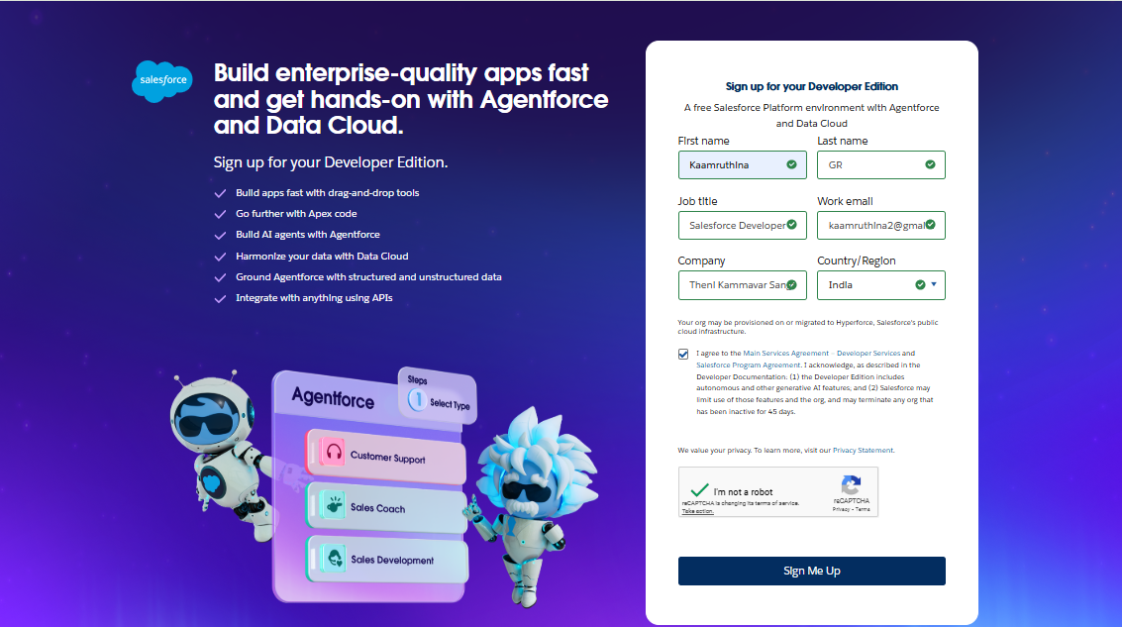

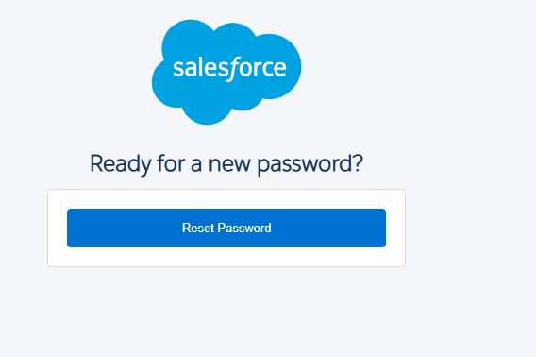 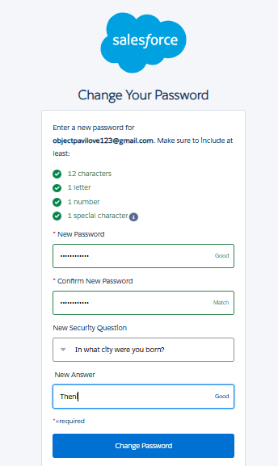

**6.2Custom Object Creation:**

We create five main custom objects for Jewel Customer, Item, Customer Order, Price, Billing.

**1.Jewel Customer**

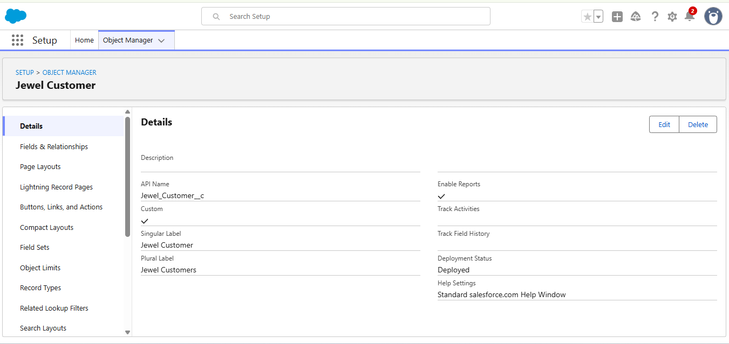

**2.Item**

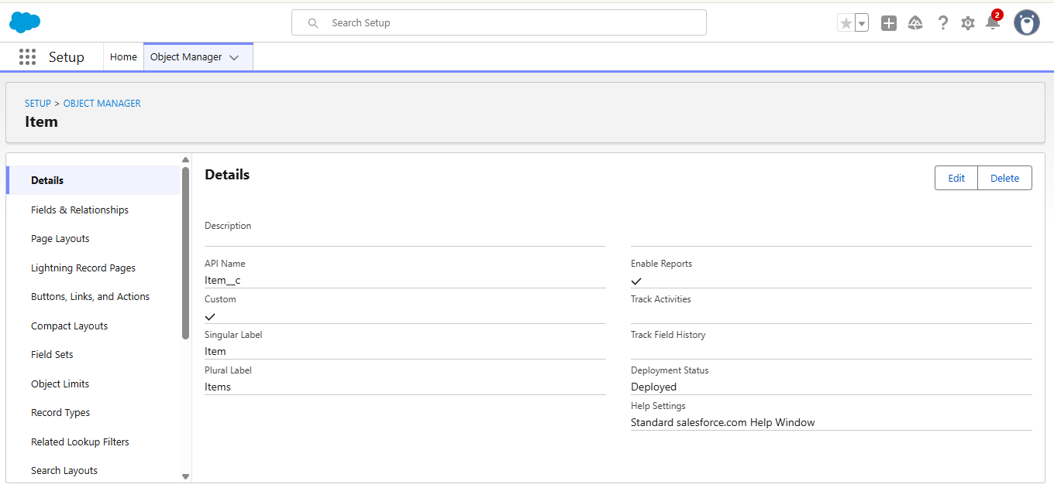

**3.Customer Order**

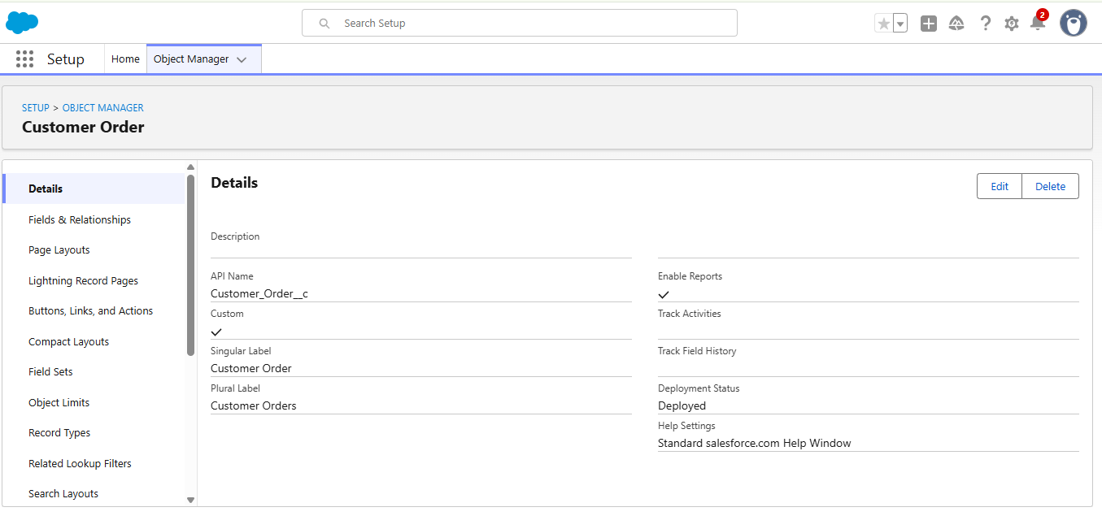

**4.Price**

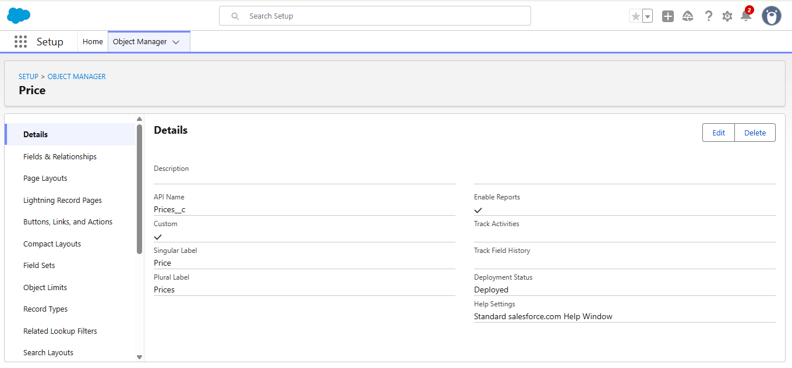

**5.Billing**

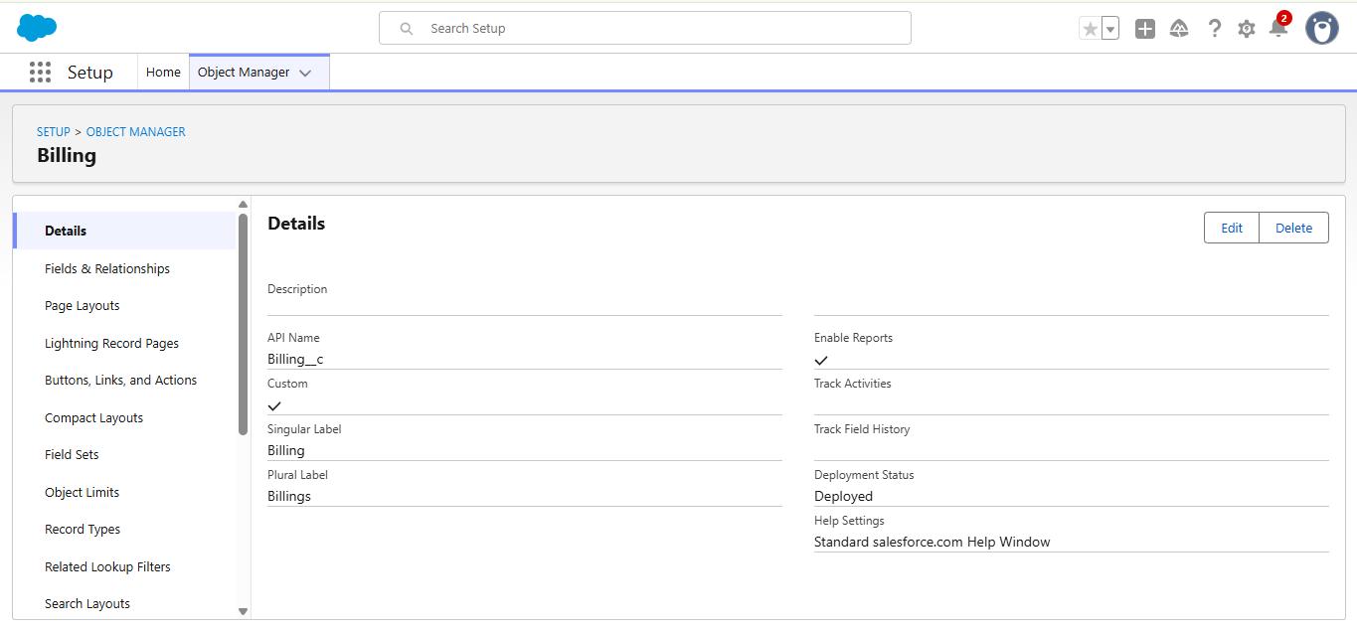

* 1. **Creation of Tabs**

We create five main custom tabs for Jewel Customer, Item, Customer Order, Price, Billing.

**1.Jewel Customers**

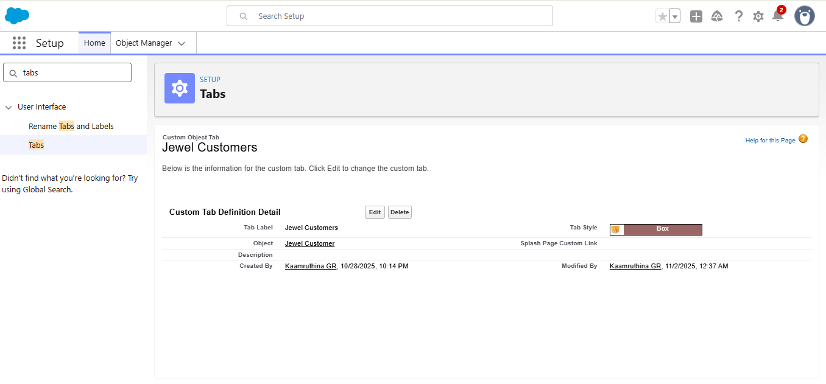

**2.Item**

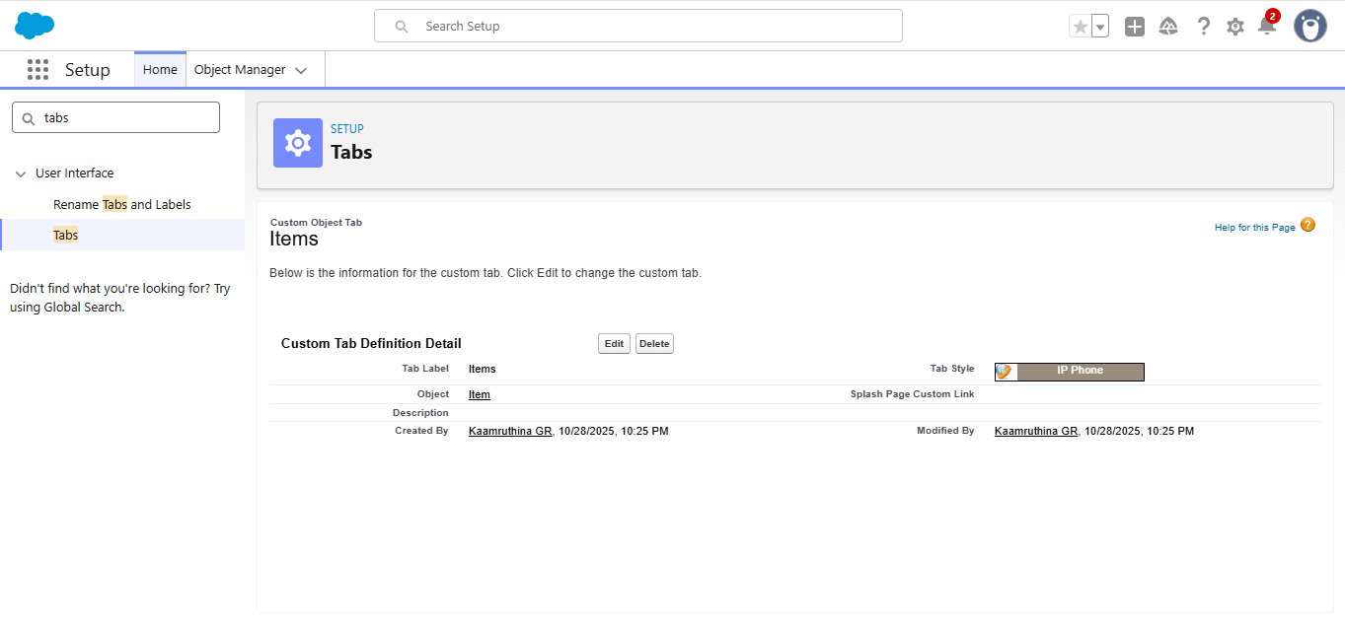

**3.Customer Orders**

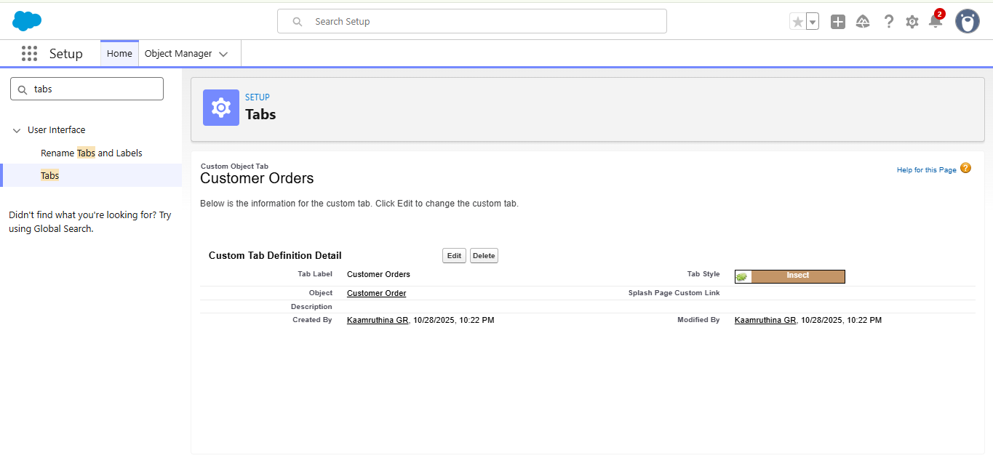

**4.Prices**

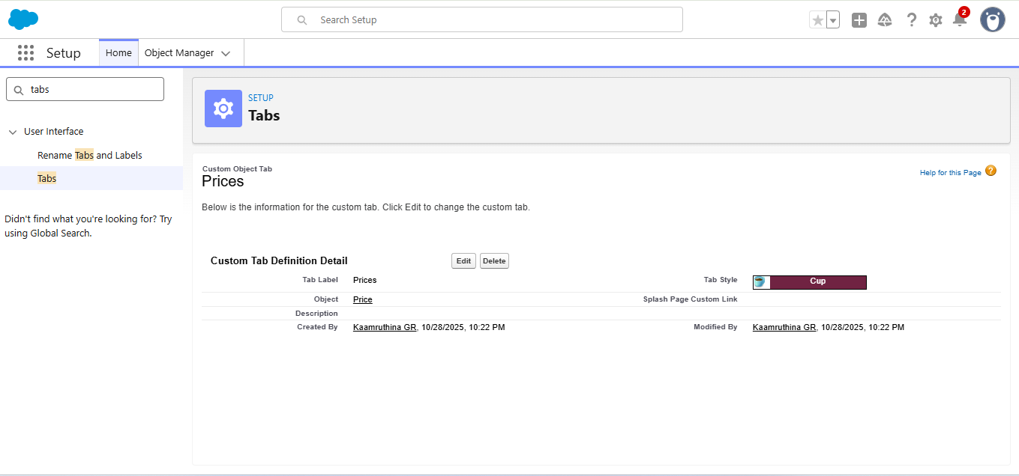

**5.Billings**

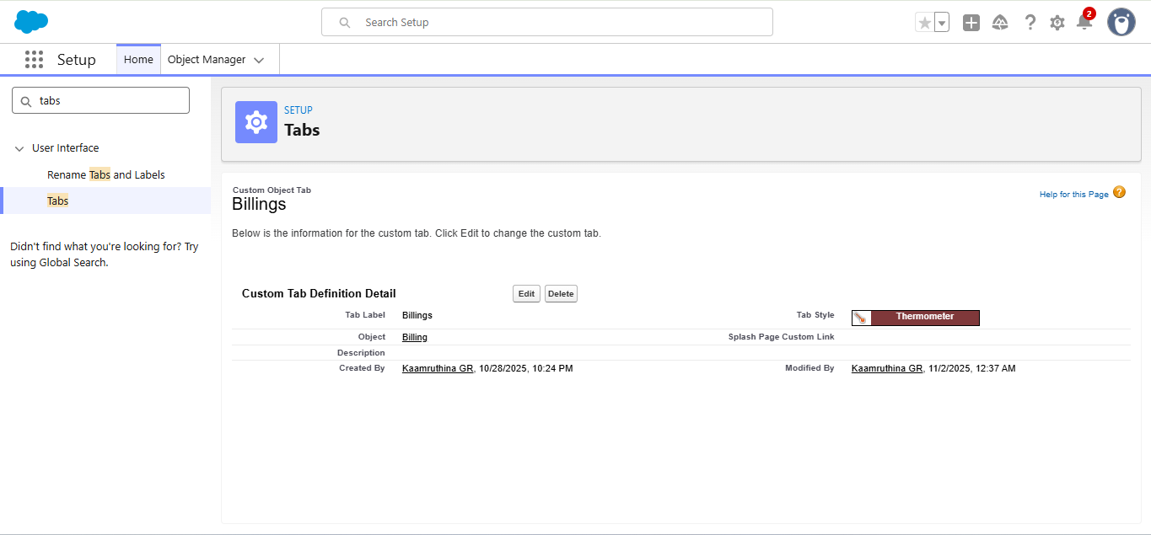

So we get the required all custom tabs as below

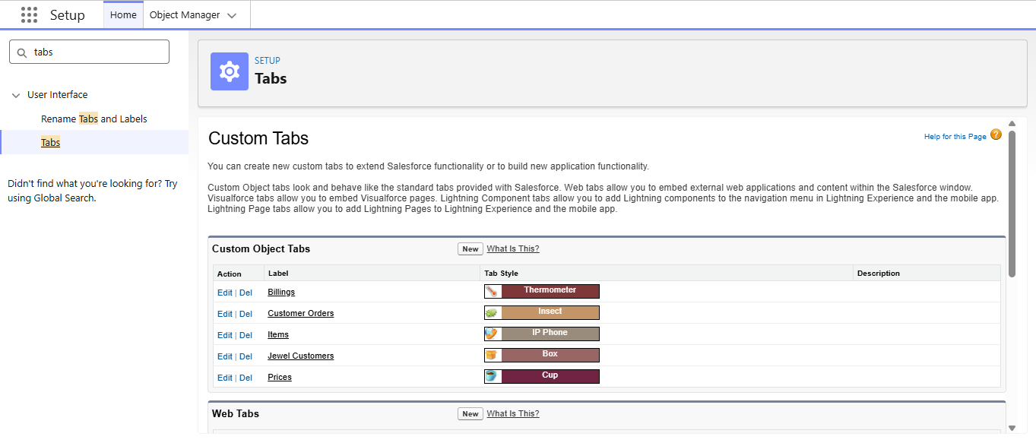

* 1. **Creation of Lightning App**

**App Name:** Jewelry Inventory System

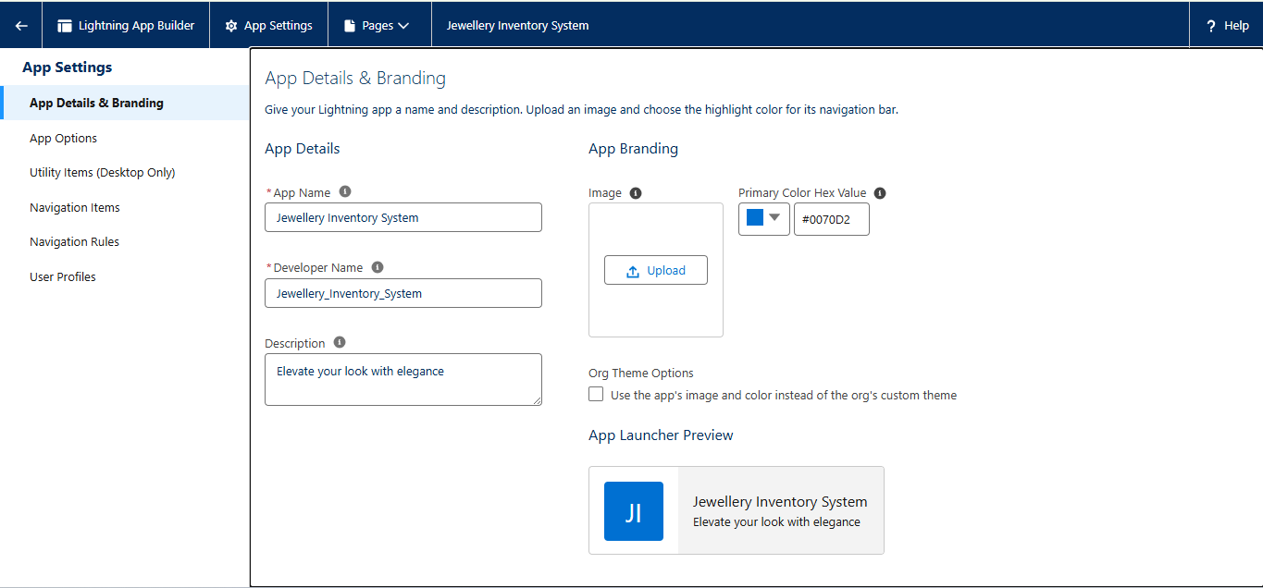

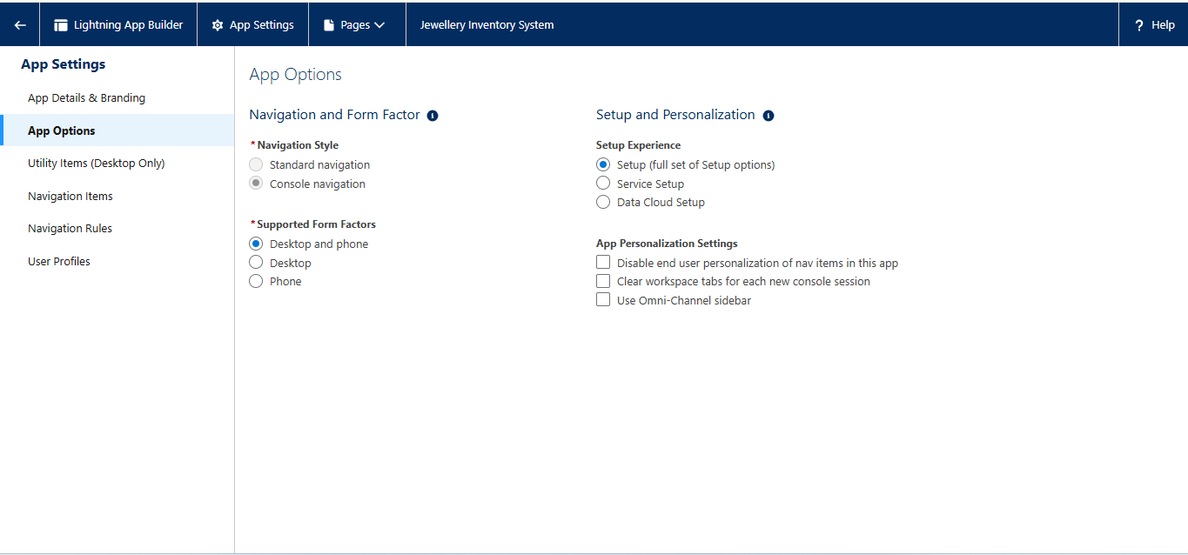

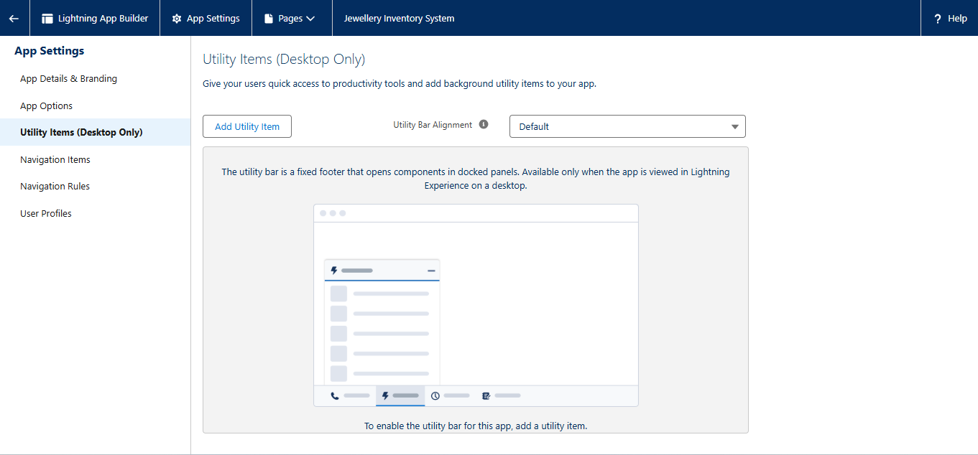

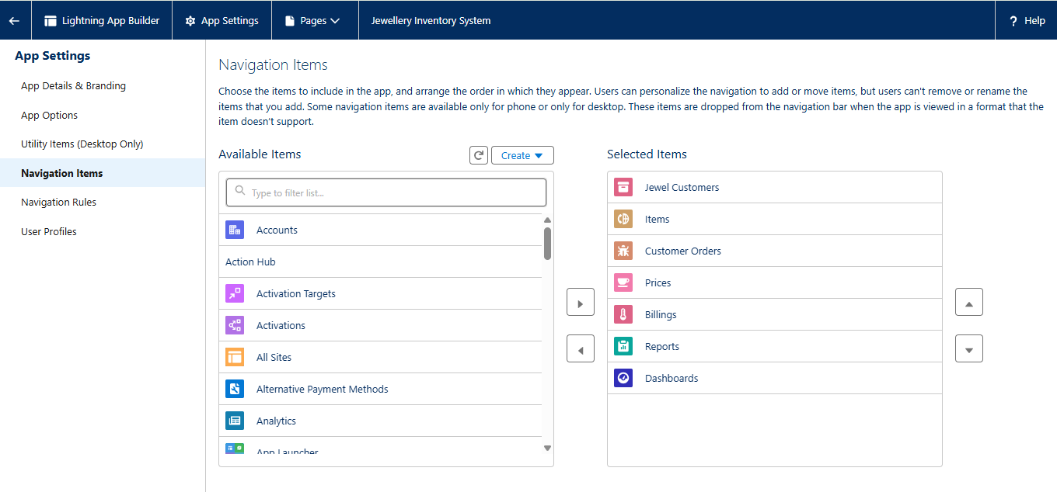

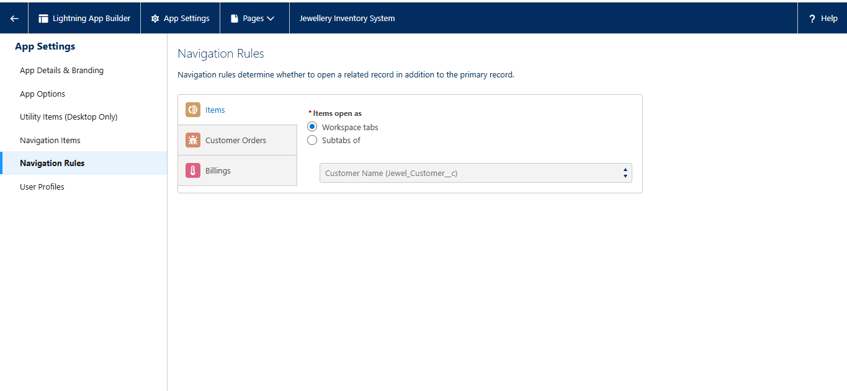

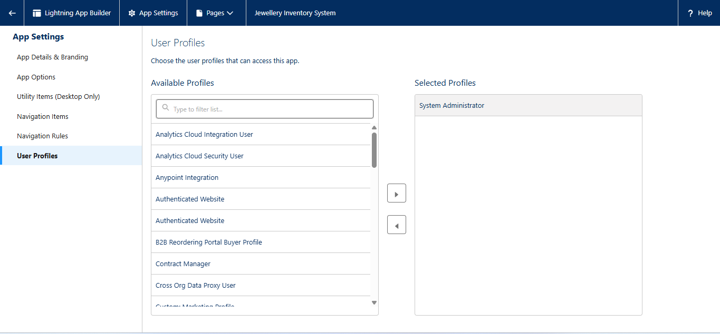

* 1. **Creation of Fields**

**1.Creating lookup relationship**

To Create a relationship between Jewel Customer & Customer Order Objects.

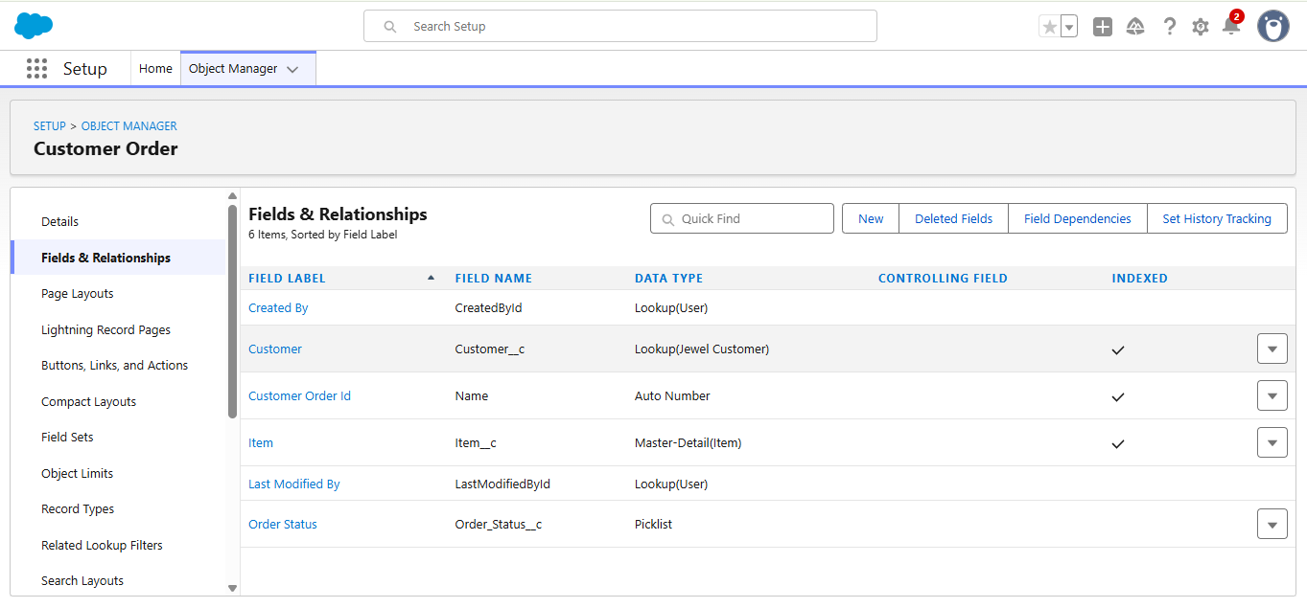

1. **Creating a Master-Oetall Relatlonshlp**

Creating Master-Detail Relationship between Item & Customer Order Object.

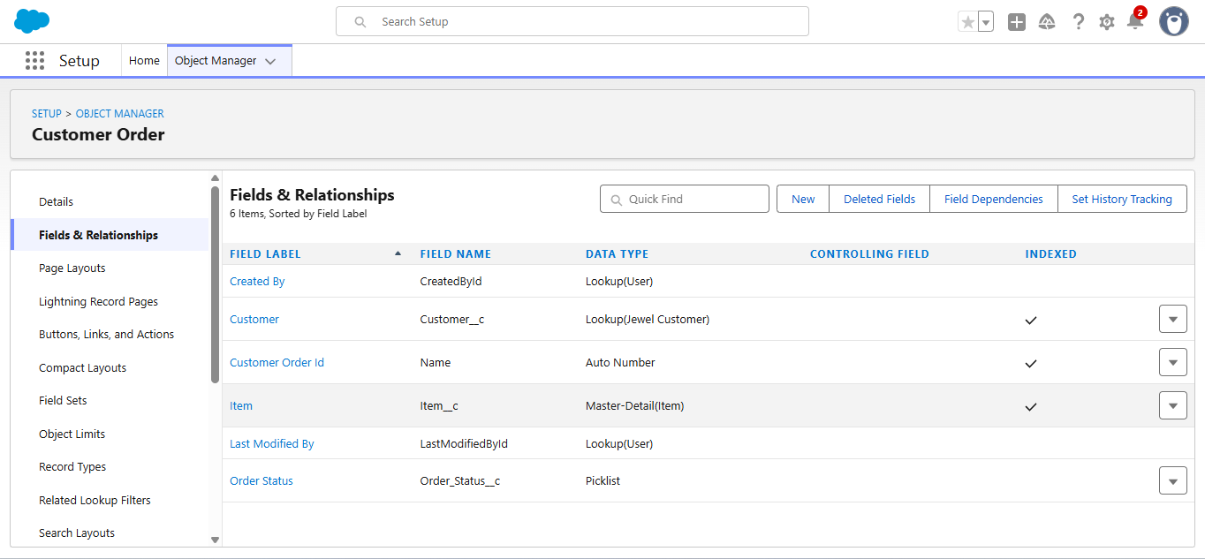

1. Creating Text Field in Jewel Customer Object

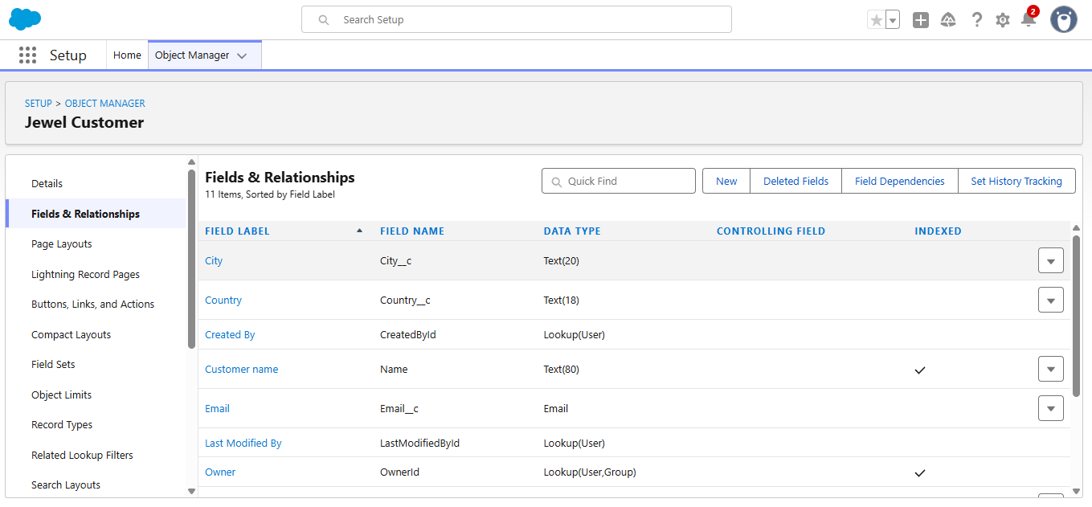

1. Creating the Phone field in object Jewel Customer

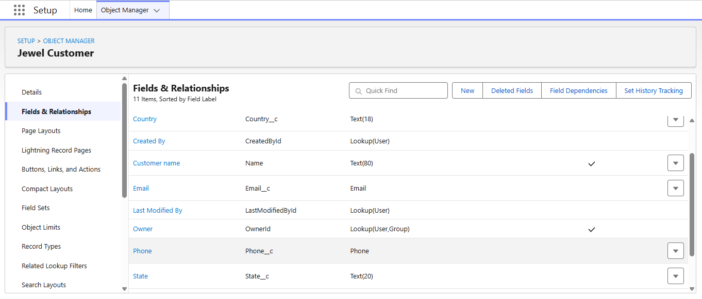

1. Creating the Email field in object Jewel Customer

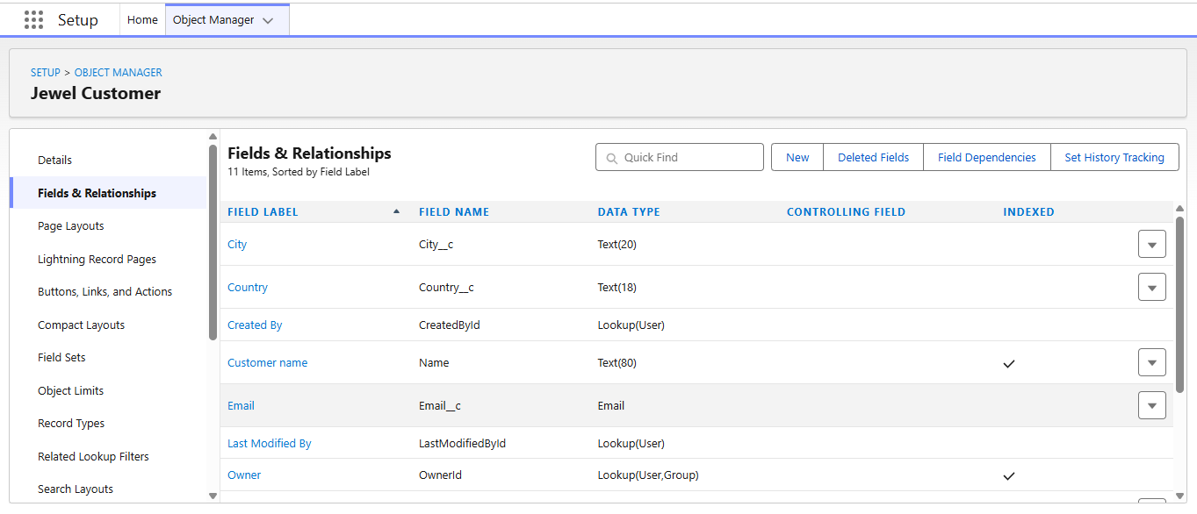

6.Creating the number field in Item object

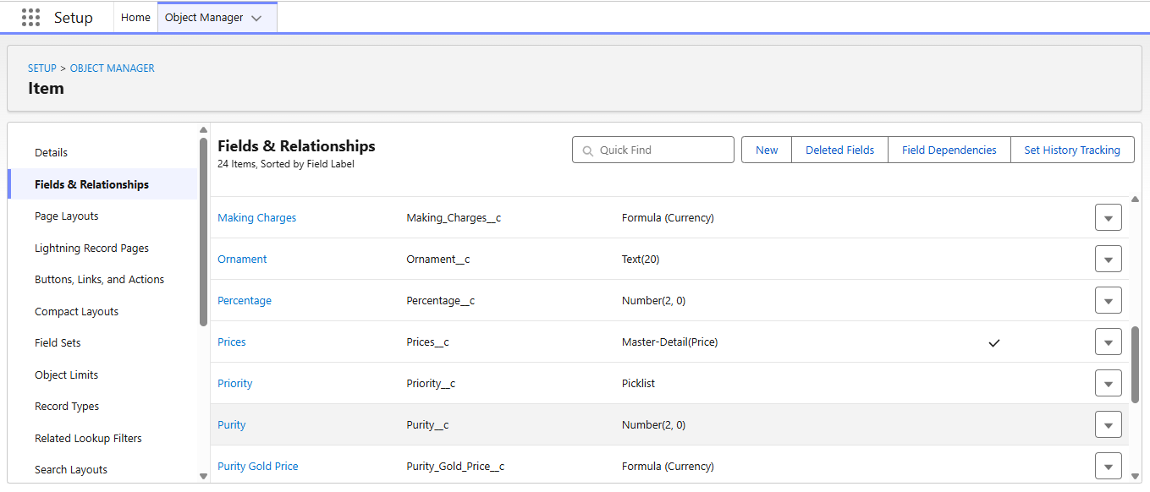

7.Creating Picklist Field in Item Object

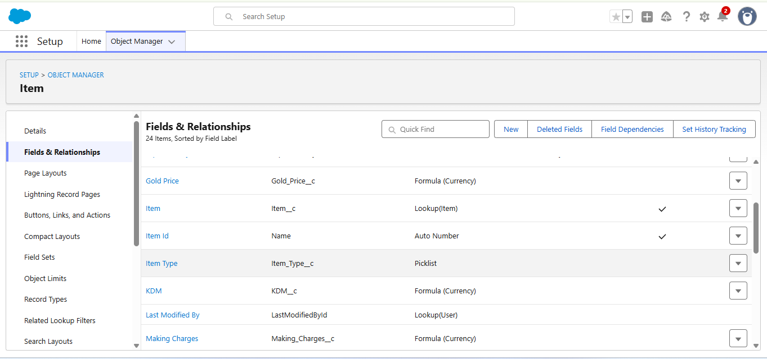

8.Creating Currency Field in Price Object

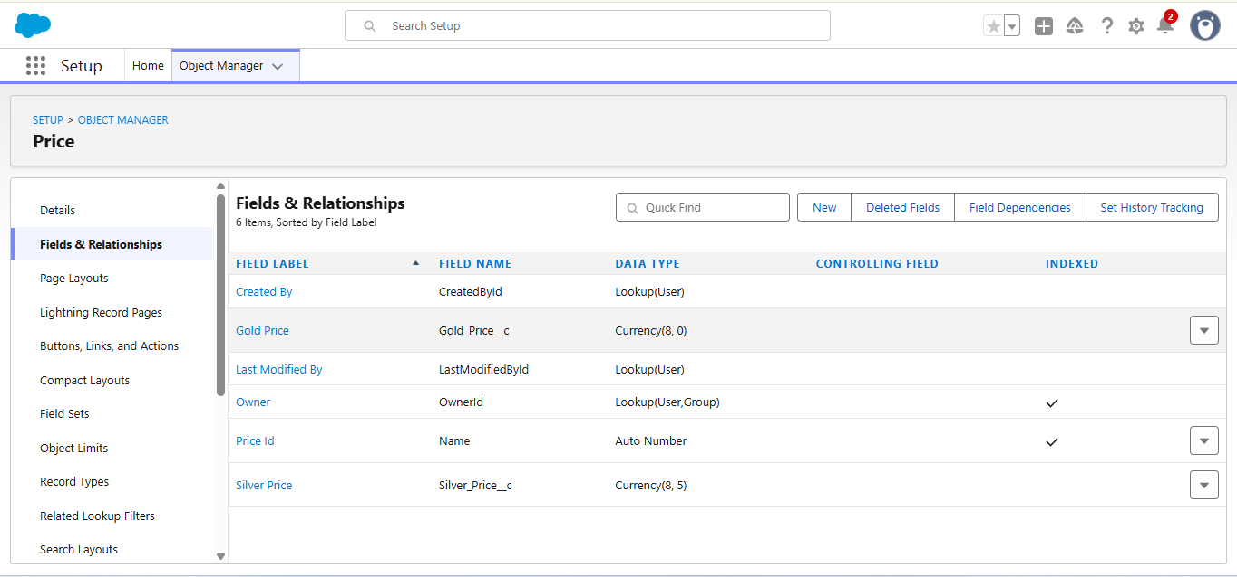

9.Creating Formula Field(Cross Object) in Item Object

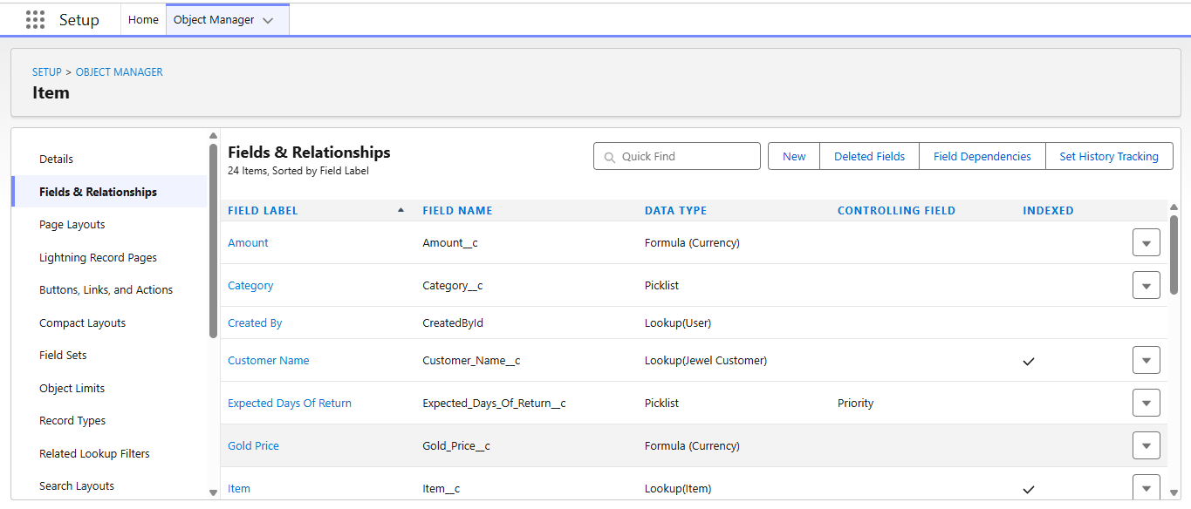

**10.Creating Remaining Fields in Objects**

**1.Jewel Customer:** State, Street, Country, Zip/Postal code

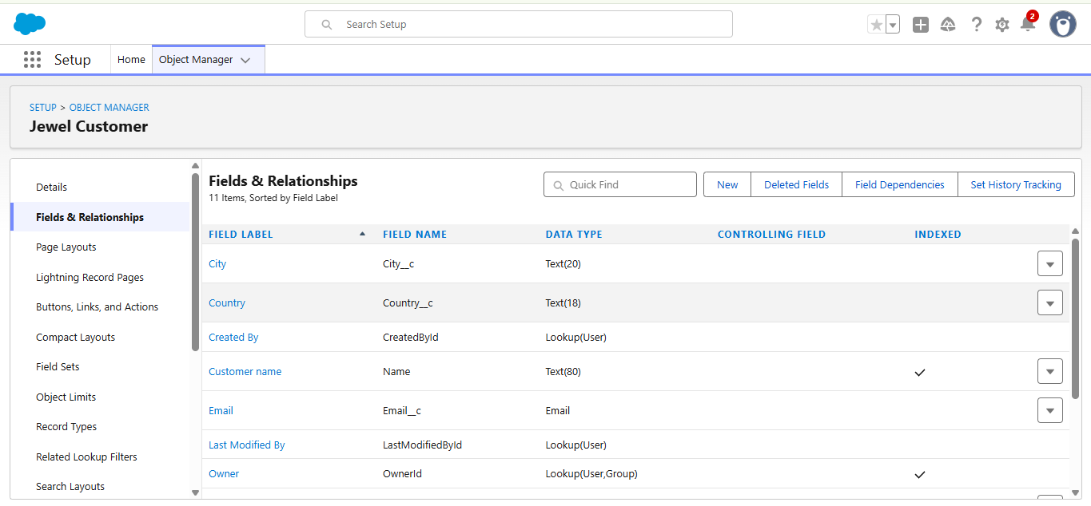

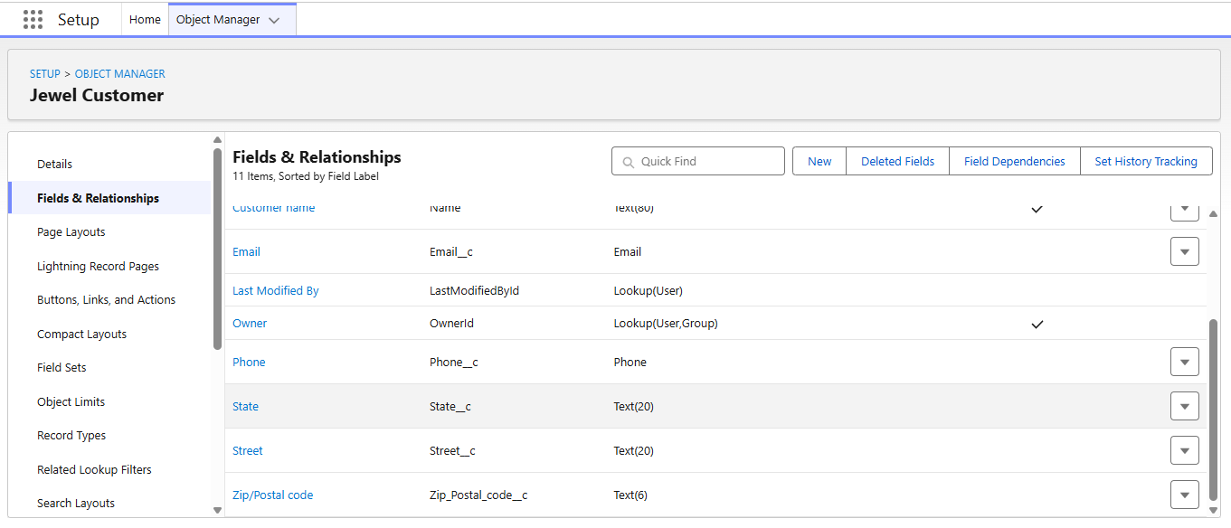

2.Price: Silver Price

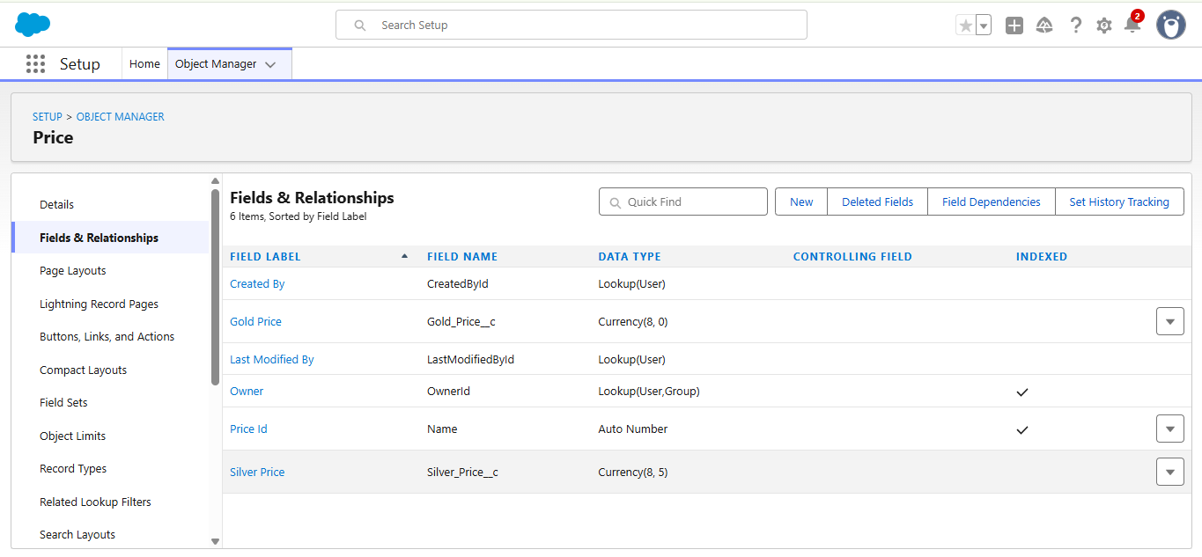

3.Item: Field Label-Customer Name, Ornament, Weight, Stone Weight, Percentage,

Stone/Other Price, Expected Days of Return, Priority, Silver Price, Purity Gold Price, Total Weights, Amount, KDM, Making Charges.

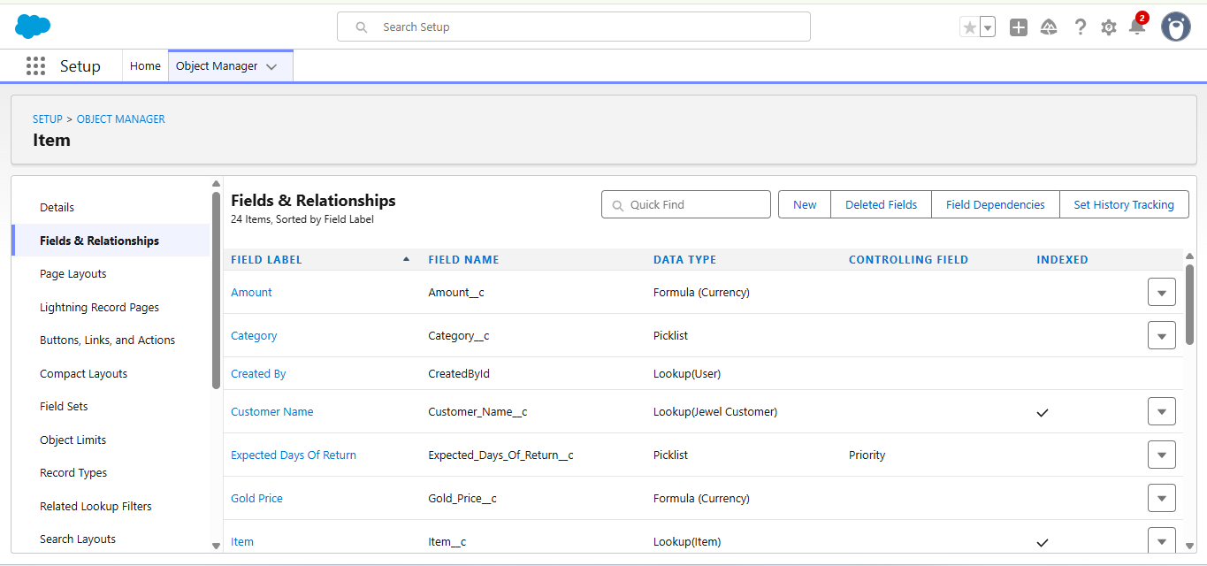

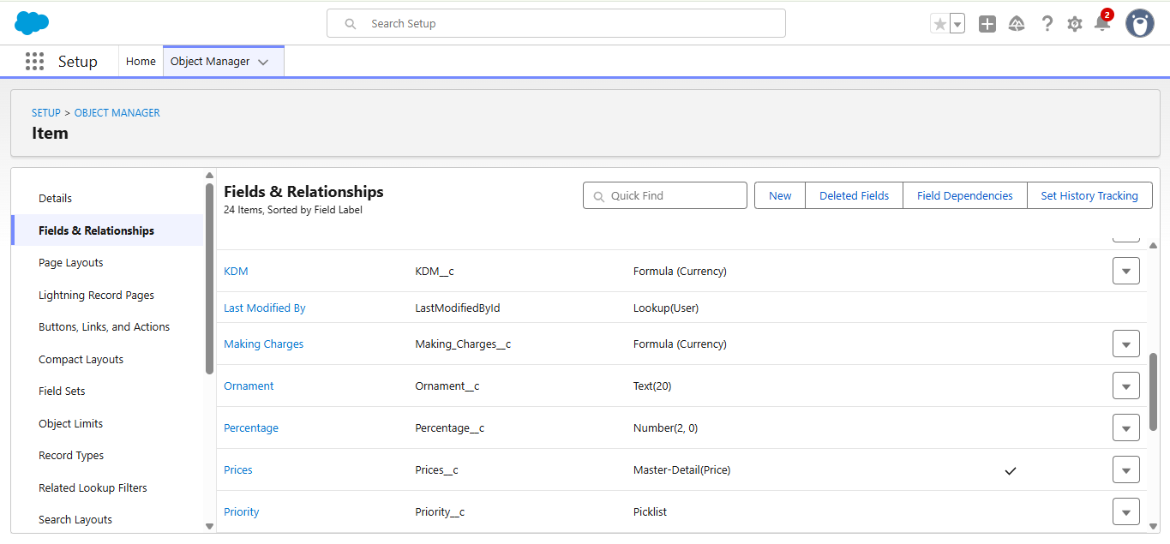

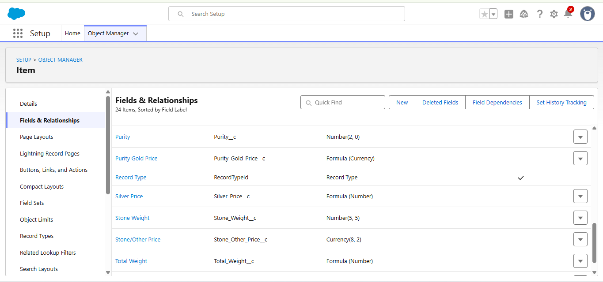

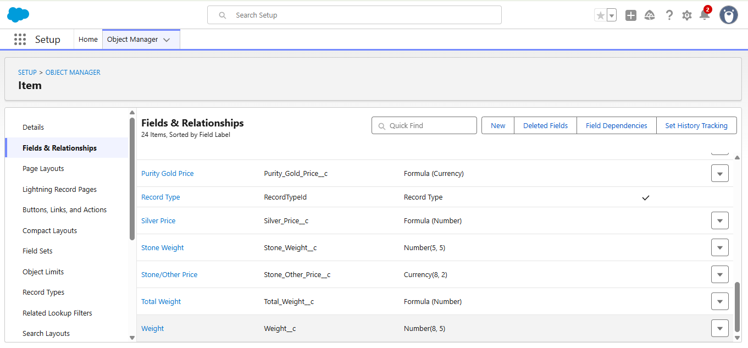

4.Customer Order: Order Status

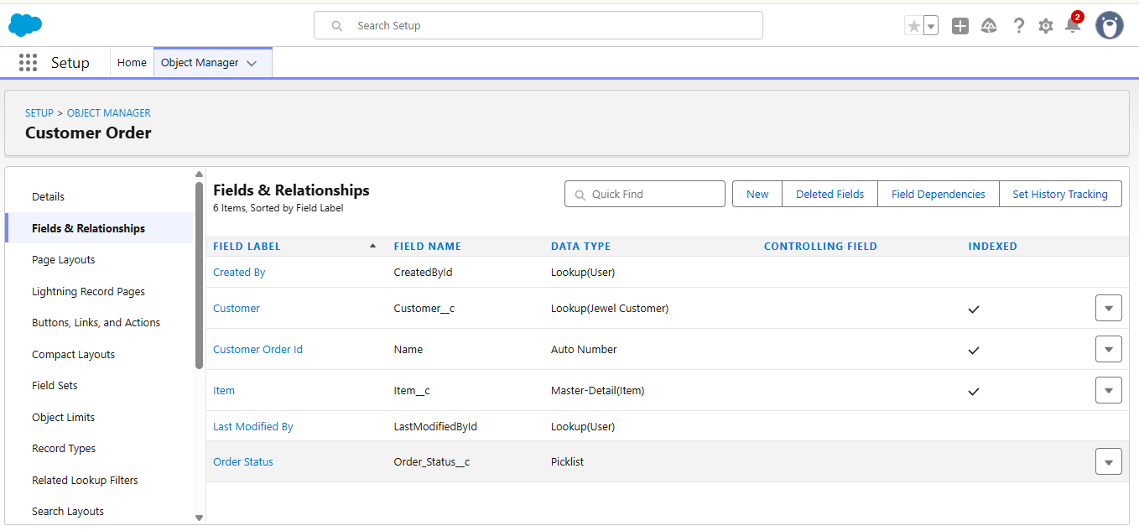

5.Billing: Field Label-Item, Ornament, Stone Weight, Weight, Amount, Gold/Silver Price, KDM Charge, Making Charges, Stone/Other Price, Total Amount.

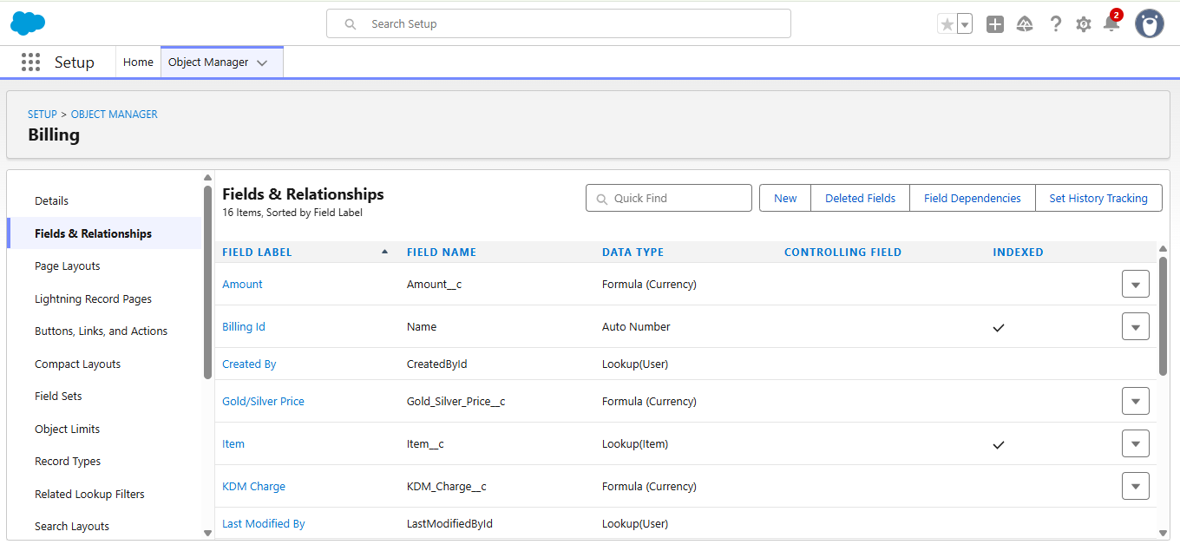

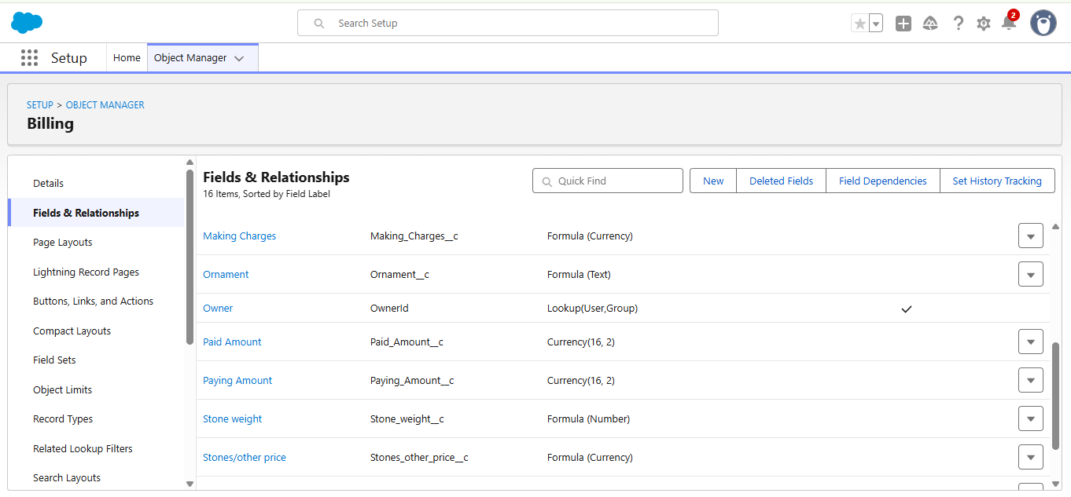

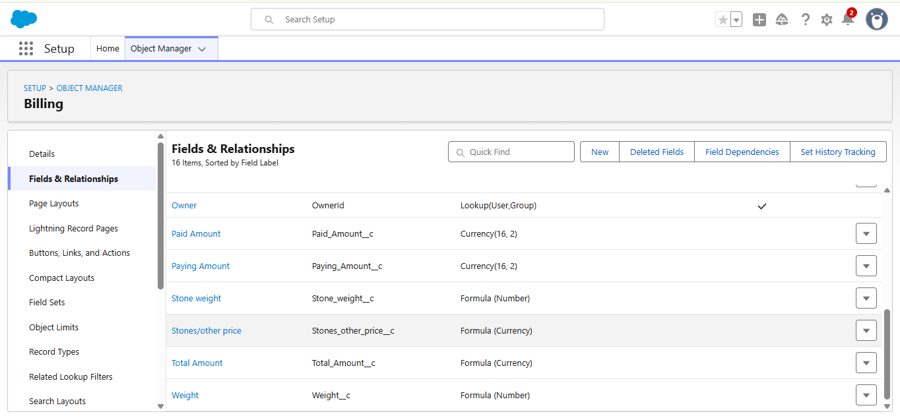

11.Creation of Schema Builder

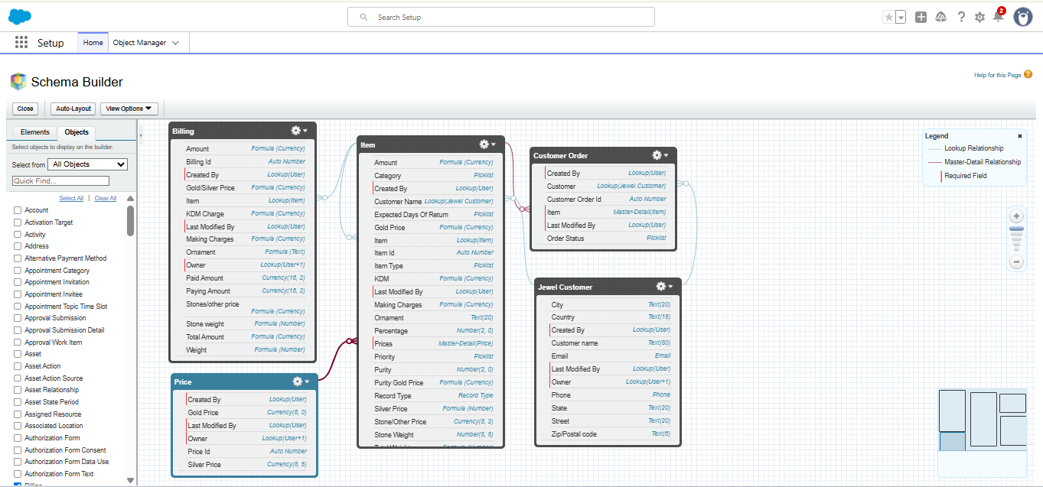

12.Creation of Field Dependencies

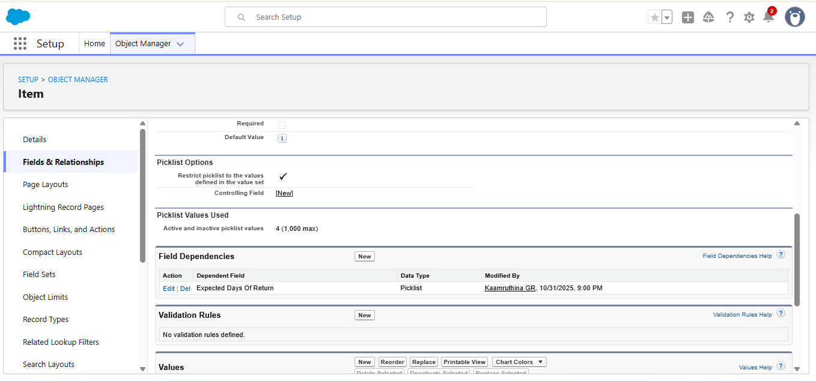

13.Creation of Validation Rules

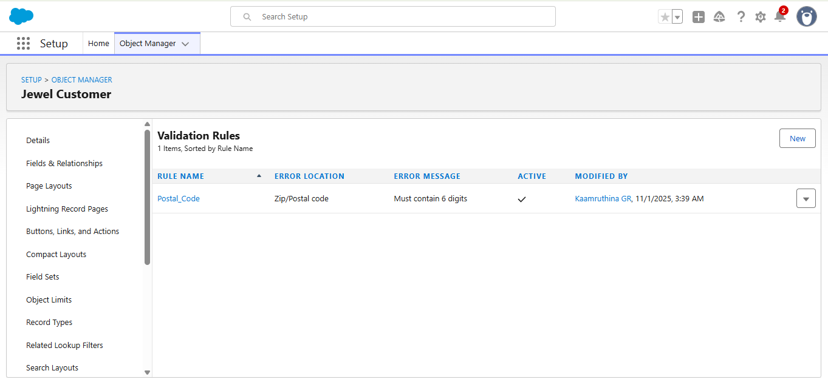

* 1. **Creation of Profiles**

We create the goldsmith profile and the worker profile

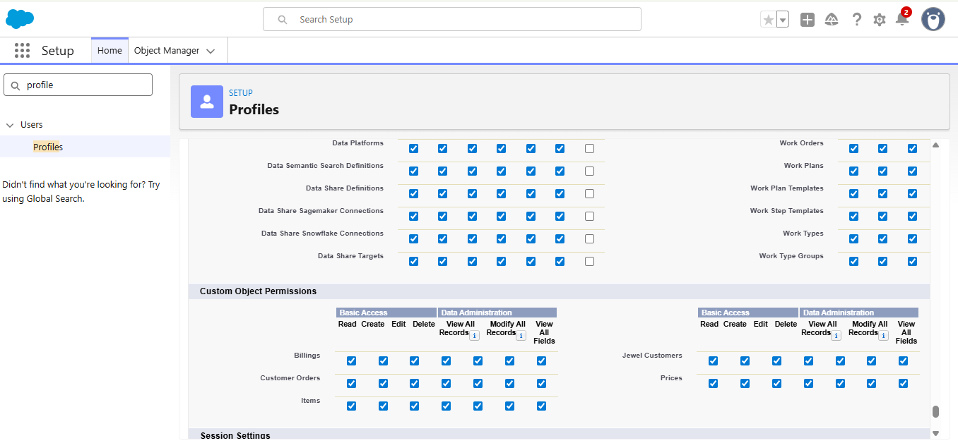

* 1. **Creation of Roles**

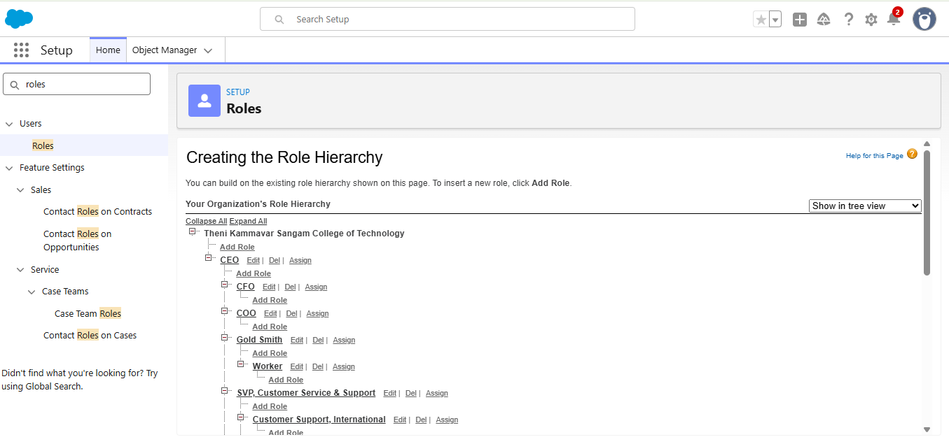

* 1. **Creation of Users**

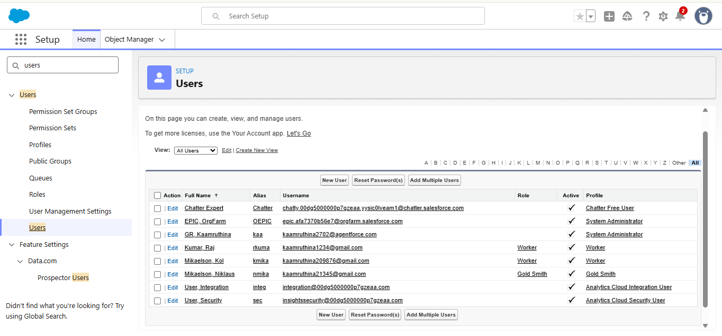

* 1. **Creation of Page Layouts**

We create the page layouts for gold and silver Items

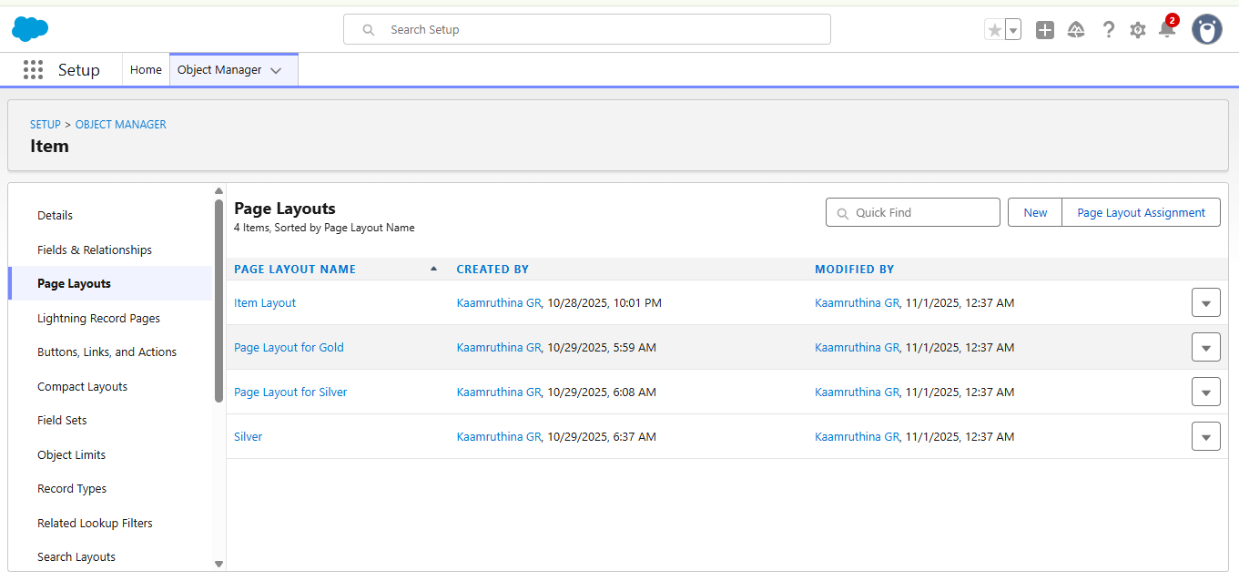

* 1. **Creation of Record Types**

We create the gold an silver records

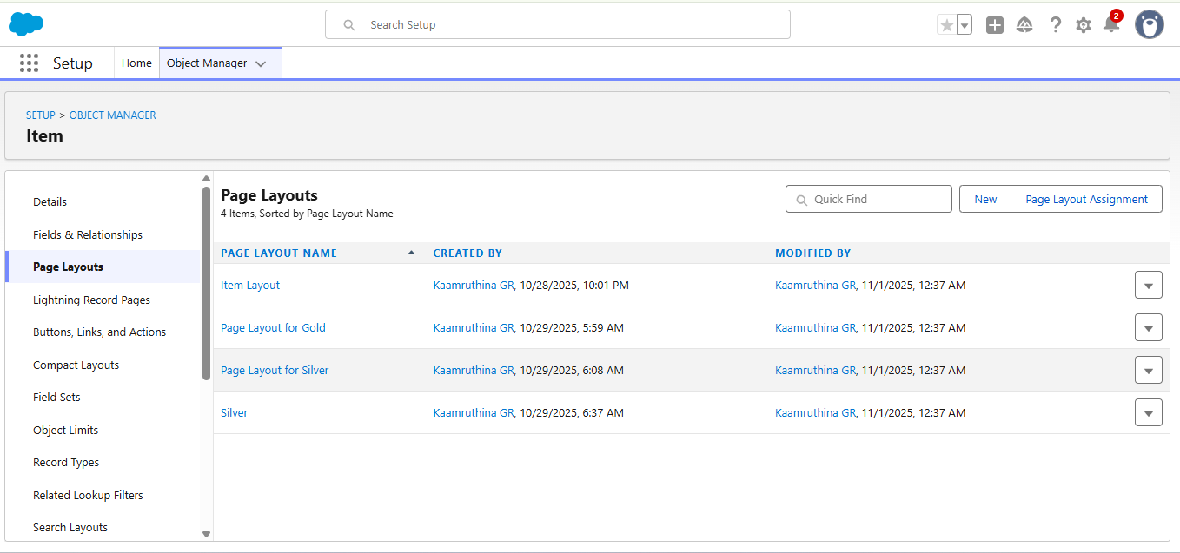

* 1. **Creation of Permission sets**

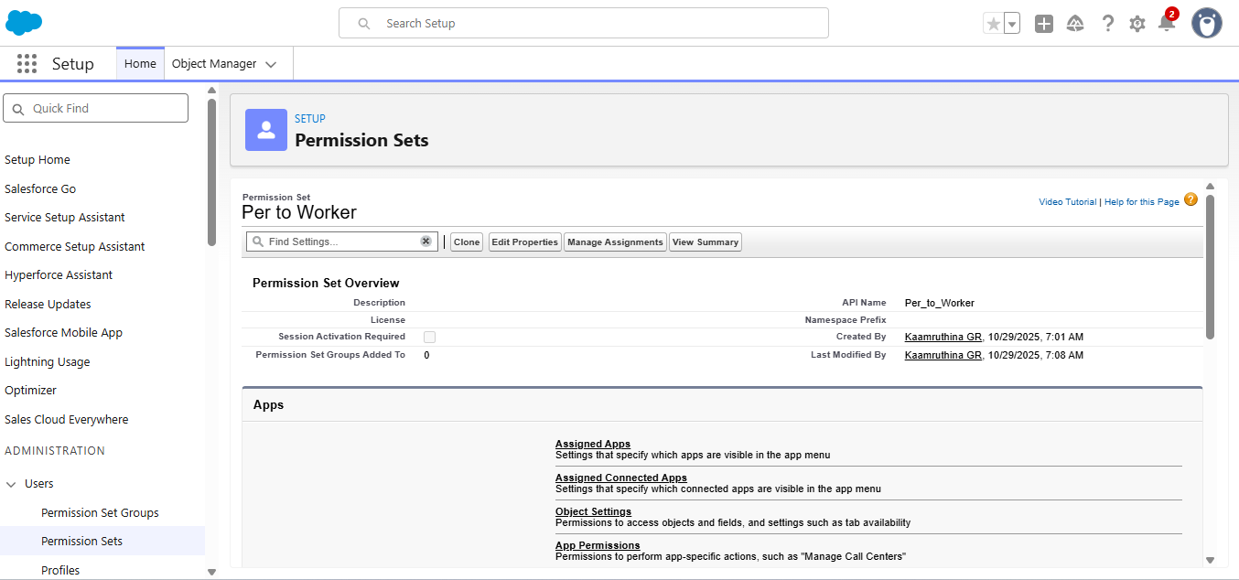

* 1. **Create a Trigger**

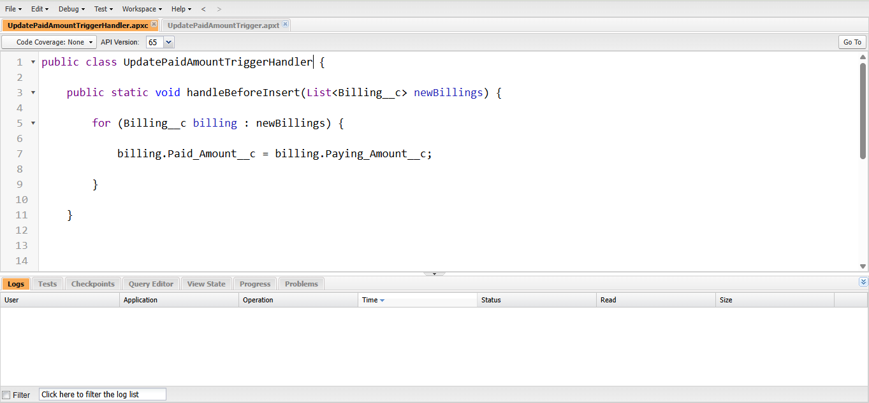

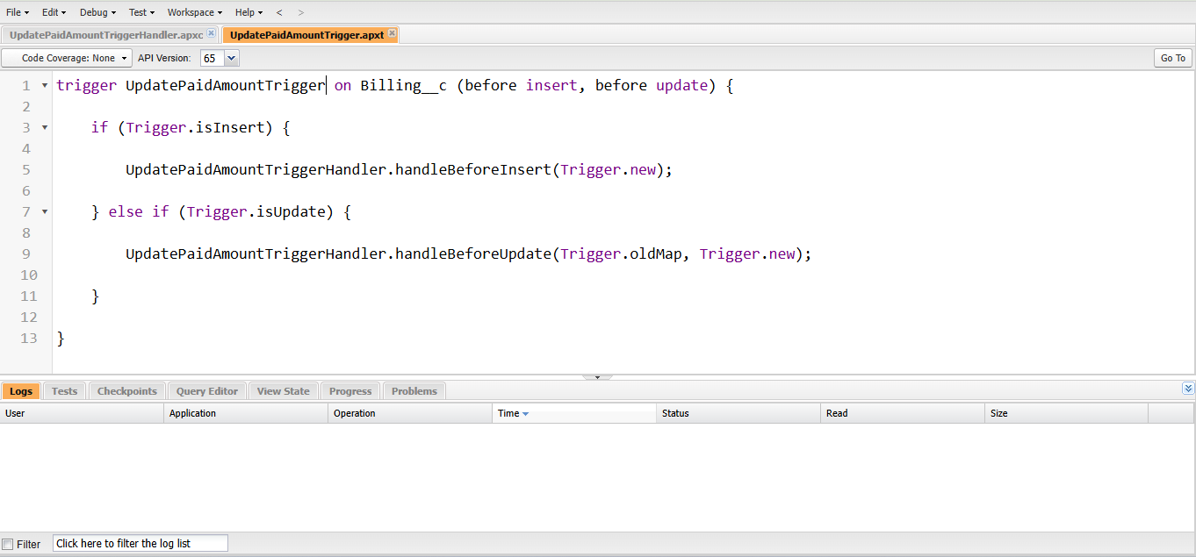

**6.13** **User Adoption**

We create Item, Price, Customer Orders, Jewel Customers and Billing

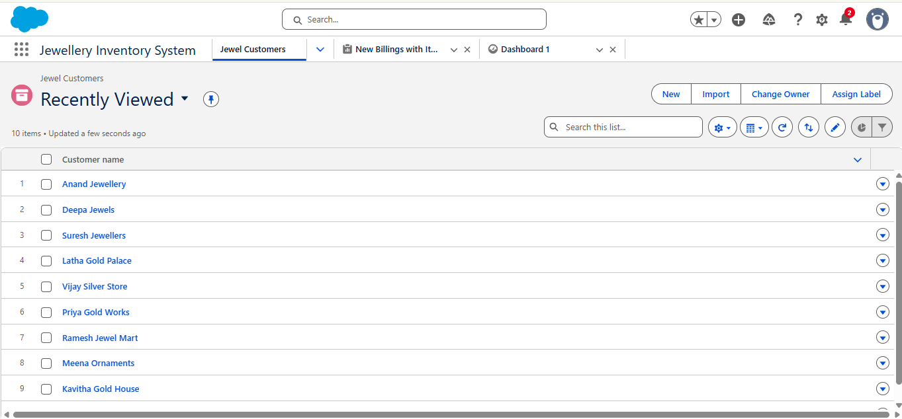

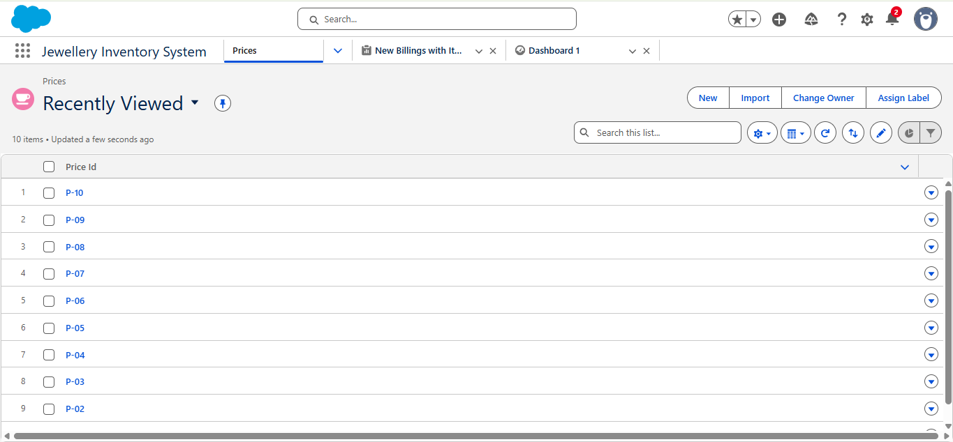

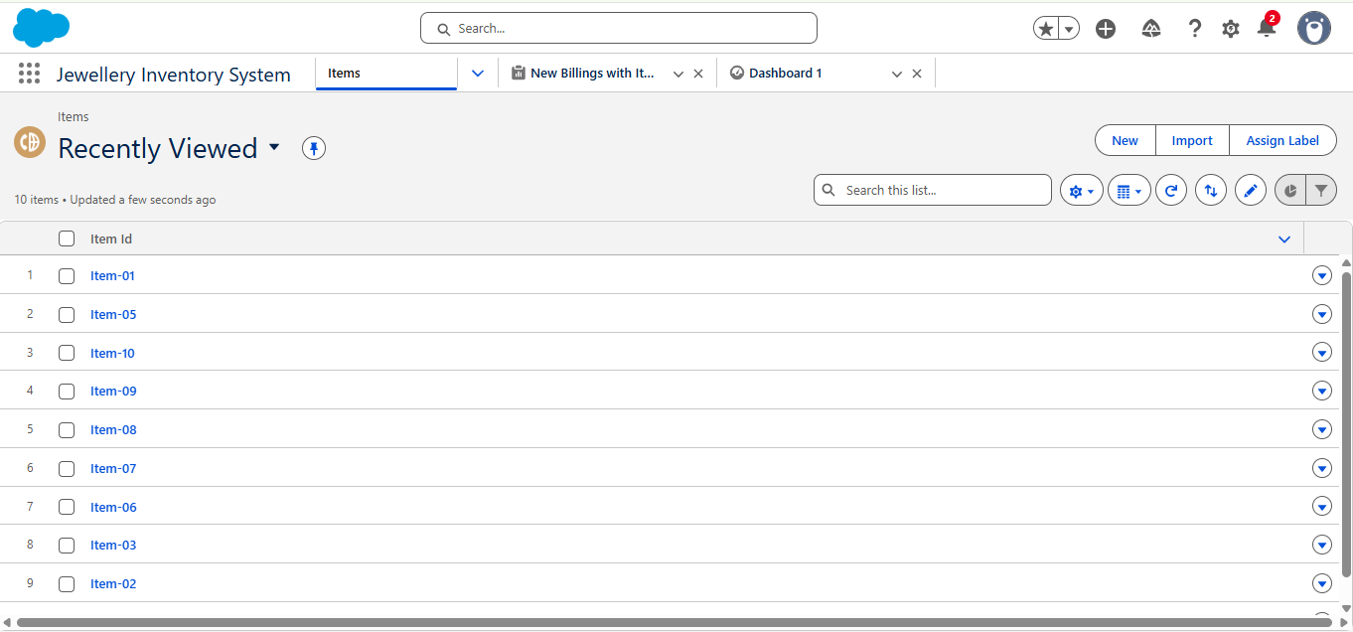

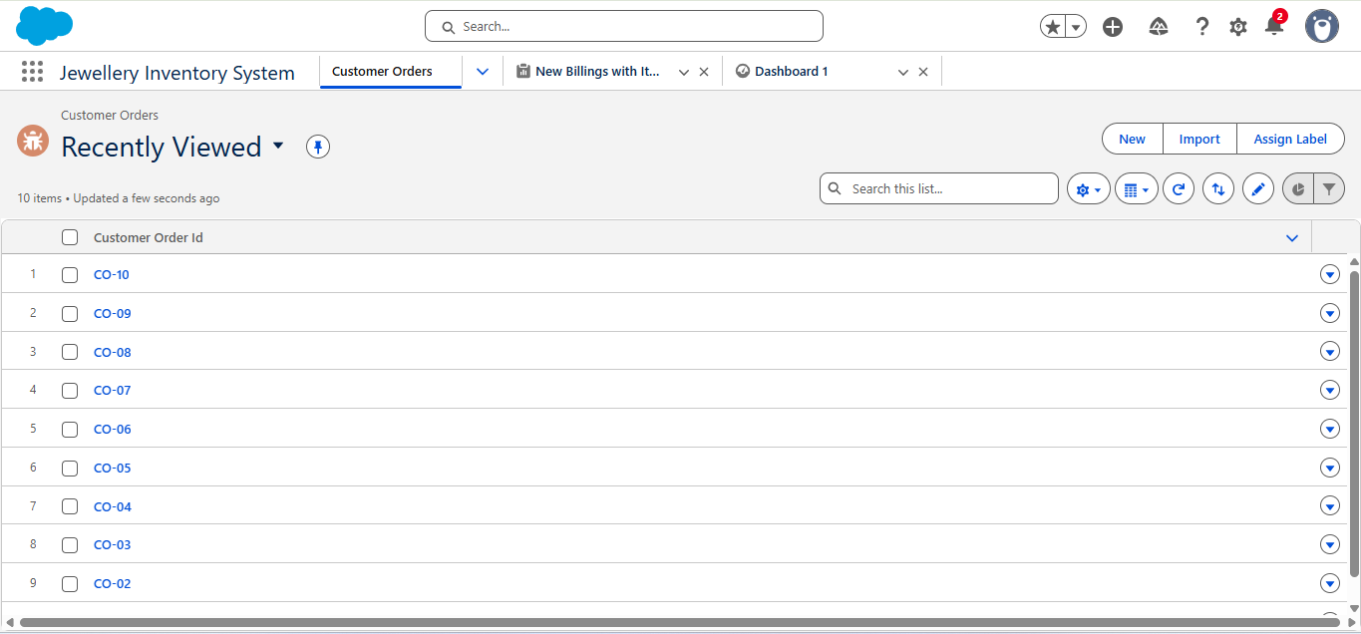

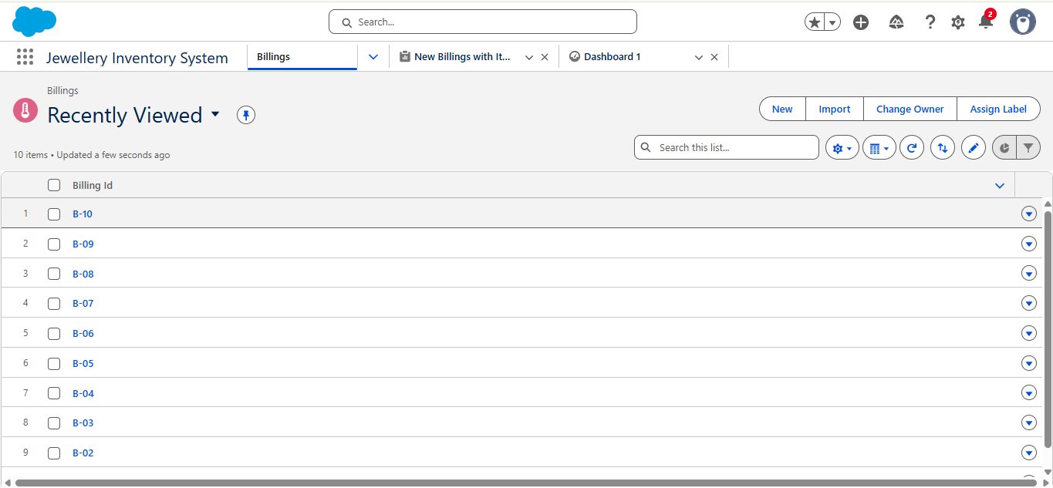

**6.14 Reports**

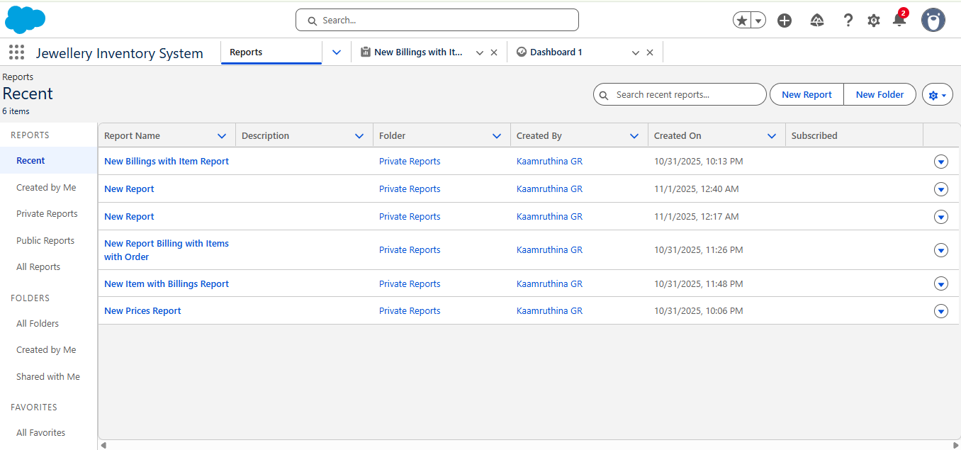

* 1. **Dashboards**

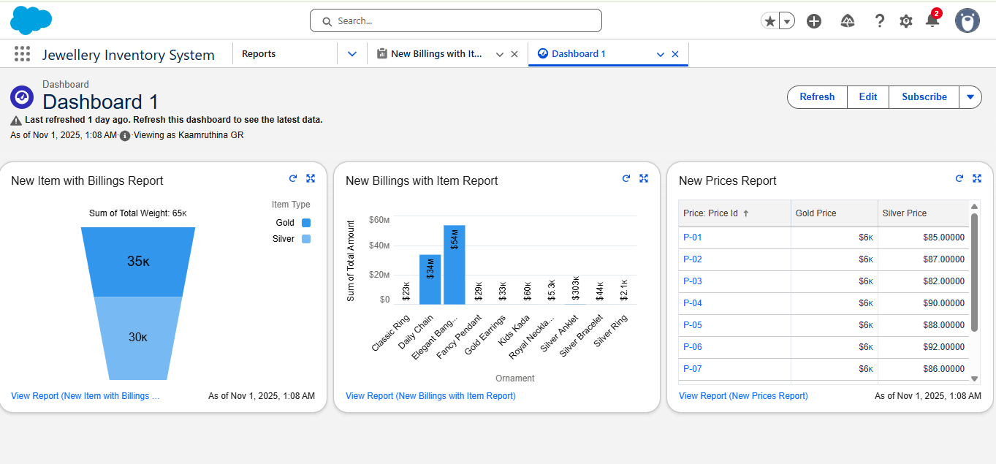

1. **Flows**

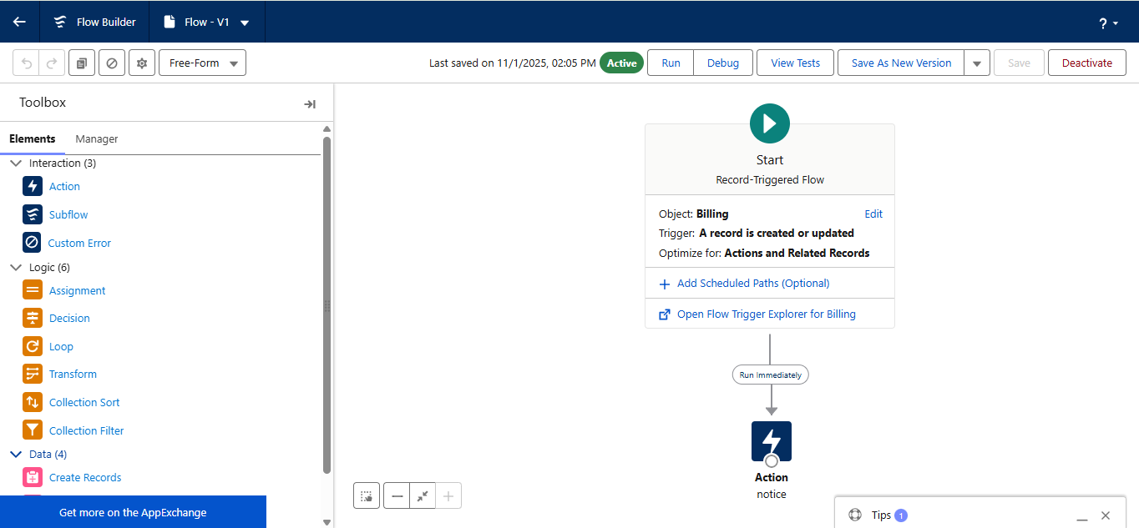

**8.Conclusion**

'In conclusion, the CRM Application for Jewel Management serves as a robust, cloud-based solution built using Salesforce. It brings digital transformation to traditional jewelry retailing by:

* Streamlining operations with custom objects and flows
* Improving business oversight with real-time dashboards
* Automating repetitive tasks like billing and inventory updates
* Enhancing data integrity and customer service

The project demonstrates how low-code too's like Salesforce Flow and Lightning App Builder can be used by developers to create enterprise-grade solutions. Our application is not only scalable and efficient but also provides a solid foundation for future business growth in the jewelry sector."

* 5. PROJECT PLANNING AND SCHEDULING
* 5.1 Project Plann

.